**SUNDAY BIBLE STUDY**

**Faith of our Fathers**

**Readings:**[**Wisdom 18:6–9**](https://biblia.com/bible/rsvce/Wis%2018.6%E2%80%939)[**Psalm 33:1**](https://biblia.com/bible/rsvce/Ps%2033.1)**,**[**12**](https://biblia.com/bible/rsvce/Psalm%2033.12)**,**[**18–22**](https://biblia.com/bible/rsvce/Psalm%2033.18%E2%80%9322)[**Hebrews 11:1–2**](https://biblia.com/bible/rsvce/Heb%2011.1%E2%80%932)**,**[**8–19**](https://biblia.com/bible/rsvce/Hebrews%2011.8%E2%80%9319)[**Luke 12:35–40**](https://biblia.com/bible/rsvce/Luke%2012.35%E2%80%9340)

**We are born of the faith of our fathers, descending from a great cloud of witnesses whose faith is attested to on every page of Scripture (see**[**Hebrews 12:1**](https://biblia.com/bible/rsvce/Heb%2012.1)**). We have been made His people, chosen for His own inheritance, as we sing in this Sunday’s Psalm. The Liturgy this week sings the praises of our fathers, recalling the defining moments in our “family history.” In the Epistle, we remember the calling of Abraham; in the First Reading we relive the night of the Exodus and the summons of the holy children of Israel. Our fathers, we are told, trusted in the Word of God, put their faith in His oaths. They were convinced that what He promised, He would do. None of them lived to see His promises made good. For it was not until Christ and His Church that Abraham’s descendants were made as countless as the stars and sands (see**[**Galatians 3:16–17**](https://biblia.com/bible/rsvce/Gal%203.16%E2%80%9317)**,**[**29**](https://biblia.com/bible/rsvce/Galatians%203.29)**). It was not until His Last Supper and the Eucharist that “the sacrifice . . . the divine institution” of that first Passover was truly fulfilled.**

**And now we too await the final fulfillment of what God has promised us in Christ. As Jesus tells us in this week’s Gospel, we should live with our loins girded—as the Israelites tightened their belts, cinched up their long robes and ate their Passover standing, vigilant and ready to do His will (see**[**Exodus 12:11**](https://biblia.com/bible/rsvce/Exod%2012.11)**;**[**2 Kings 4:29**](https://biblia.com/bible/rsvce/2%20Kings%204.29)**). The Lord will come at an hour we do not expect. He will knock on our door (see**[**Revelation 3:20**](https://biblia.com/bible/rsvce/Rev%203.20)**), inviting us to the wedding feast in the better homeland, the heavenly one that our fathers saw from afar, and which we begin to taste in each Eucharist. As they did, we can wait with “sure knowledge,” His Word like a lamp lighting our path (see**[**Psalm 119:105**](https://biblia.com/bible/rsvce/Ps%20119.105)**). Our God is faithful, and if we wait in faith, hope in His kindness, and love as we have been loved, we will receive His promised blessing and be delivered from death. –**

***The St. Paul Center for Biblical Theology***

***Visit our webpage!***

[***www.saintanthonyblueridge.com***](http://www.saintanthonyblueridge.com)

**K-12 Religious Education**

***Classes began Wednesday, September 19th.***

**St. Anthony “Wish List”**

**☺ ☺☺☺☺☺☺☺**

***Renovations for “Tony’s Place”- Our CCD building is in great need of repairs! If you would like to donate towards this wish, please write “Tony’s Place” on the bottom of your check & drop in collection basket. Throw your loose change in the Big Coke Bottle too! Thank you in advance!***

**☺☺☺☺☺☺☺☺**

**2nd Collections for Aug & Sept**

**Aug. 18th – Local STVDP**

**Sept. 1st – Cath. Univ.**

**Sept. 15th – Local STVDP**

**Sept. 22nd – Atlanta STVDP**

**Interested in joining the Knights of Columbus?** 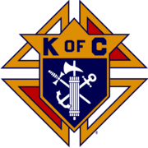

[**www.kofc.org/join**](http://www.kofc.org/join)

**or**

**Call Tom Brown @**

**678-787-3028**



**If you would like to have flowers in memory or in honor of someone, please call the office.**

MC900048039[1]

PRAYERS FOR OUR

PARISHIONERS

***Pray for the soul of*:**

**Alanna Popovich, Bill Adamson, Glenn McFarland Jr., Linda Traupane, Billy Shaw, Louise Ciamillo, Bobby Wayne, & Amber Aiello’s grandma.**

***Please pray for:***

**Mary McFarland, Richard Waddell, Raymond O’Keefe, Bruce Culbert, Doris McGowan, Rose Schwartz, Kathy Suvada’s daughter Nikki, Gene Bishop, Virginia Hastings, Ruth McCart, Patti LaRosa, Bob Bender, Mary Arp, Matt Guilfoyle, Lorraine Reynolds, Lou Ciamillo & Family.**

***Please pray for:* the safety of our marines, soldiers, sailors Luke Malonis, Sean Hastings, Phillip Thomas, John J. Banaghan, Carlos Rodriguez, Christopher, Greg Langas, Jeff Longhurst, Nicholas Horton, Josh Adkison, Chris Jones, David Rogers, Anthony Clark Yebba, Edward Bowen, Matthew & Patrick Mills, Michael Waranis, Clayton Cornell, Taylor Biggers, Anthony Difiore, & Donald P. Lozano. PLEASE LET US KNOW IF A NAME NEEDS TO BE ADDED OR REMOVED FROM THE LIST. We will delete names after 30 days**

http://www.johnmbecker.com/content/uploads/2013/02/collection_plate.jpg

**Last week’s Collections**

**07-27-19 Offer. $1655.00**

**07-28-19 Offer. $1933.00**

smiley-face-wallpaper-widescreen-001-1s4h0du[1]

**We thank you for your continued support of our parish! If you missed a prior collection, you may drop your envelope in the next collection. We are so grateful for our wonderful parishioners and visitors!**

**RCIA & Adult Classes**

**RCIA- Sundays 9am-10am. -See Fr. John**

**Adult Ed: Every Sunday morning @ 9:30am in the parish hall with Dcn. John.**



***Our Works of Mercy Group***

**Many Thanks from the Works of Mercy Team for your generous donations of school supplies for Fannin Co. Elementary Schools! You donated more than 125lbs of supplies for needy students! What an awesome gift of mercy! Thank you so much!**



**MASS INTENTIONS**

**Mon. Aug. 12th -9:00am Mass**

***No Mass Intention Scheduled***

**Tues. Aug. 13th - 9:00am Mass**

***No Mass Intention Scheduled***

**Wed. Aug 14th - 9:00am**

**Mass –**

***No Mass Intention Scheduled***

**\*\*Wed. Aug 14th – 7:00pm Mass-Vigil for The Assumption of the Blessed Virgin Mary**

***Ron Warner- Sp. Int. –“Healing” C:\Users\nbailey\AppData\Local\Microsoft\Windows\INetCache\IE\QW85JXW1\Praying_Hands[1].jpg***

**Requested by: Russell & Vayla Cornell**

**\*\*Thurs. Aug. 15th – 11:00am Mass-The Assumption of the Blessed Virgin Mary- Holy Day of Obligation**

***No Mass Intention Scheduled***

**Fri. Aug. 16th -7:00lm Mass**

***No Mass Intention Schedule***

**Sat. Aug. 17th – 9:00am Mass-**

***No Mass Intention Schedule***

**Sat. Aug. 17th – 4:00pm Mass**

***Ollie Banach-RIP C:\Users\nbailey\AppData\Local\Microsoft\Windows\INetCache\IE\H5SZIAJA\cross___rose_by_hitenshi16-d6gzdot[1].png***

**Requested by: Dale & Judy Banach**

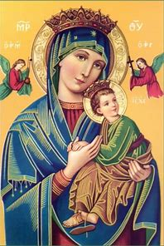

***Our Lady of Perpetual Help Fundraiser***

**Mary Arp will be here on Saturday and Sunday August 31st and Sept. 1st to sell tickets for Our Lady of Perpetual Help Cancer home in Atlanta. The home is run by Dominican nuns who provide free hospice care for the terminally ill. Tickets are $1 each or 6 for $5. Prizes will be announced later.**

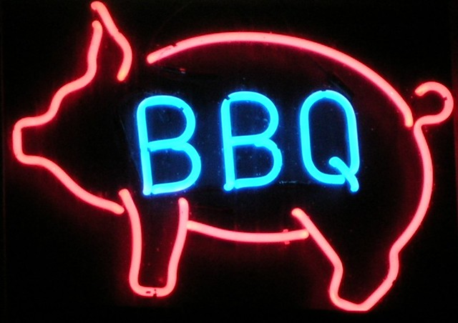

***2019 Labor Day BBQ***

**The Labor Day Bar-B-Q is faithfully held on the first Monday in September, rain or shine.  In this uniquely cooperative effort, Charismatic, Baptist, Catholic, Disciples of Christ, Episcopal, Lutheran, Methodist, & Presbyterian Churches join hands across denominational lines to raise benevolent funds to help Fannin County neighbors in need. The Labor Day Bar-B-Q Weekend is sponsored by the Good Samaritans of Fannin County, an interdenominational association of churches. Maria Rowse will have sign-up sheets for those of you that would like to help at the BBQ. It takes a large group of community churches to put on the Labor Day BBQ and they need your help!**